Welcome to St Peter’s After School Care

Dear Families.

We are so excited to welcome you to St Peter’s After School Care.

The service aims to provide leisure based, social learning experiences for children in After School Care through the dedication of our qualified educators so that we can support each child’s spiritual, physical, social, intellectual, and emotional abilities.

We would like to share some information regarding the commencement of the year:

- Contacting the OSHC service is vital if your child if away sick, gone home from school during the day, or is attending the OSHC on a day they usually do not attend. Fees and Booking procedures are outlined in the Family Handbook please read this information.
- Our OSHC service operates under the Regulatory Authority-The Department of Education and Care and therefore we abide by the National Education and Care Services Act and Law. Please take the time to visit the Framework document for OSHC website - My Time Our Place: https://www.education.gov.au/my-time-our-place

- Enrolment Information
Please ensure the following documents are provided to finalise your child’s enrolment (if you have not done so already):
- Your child’s Enrolment Form
- Your child’s Immunisation documents
- Birth Certificate or confirmation of date of birth on a recognised State or Federal Government document
- Direct Debit
- Any health care information to accompany the child’s enrolment. e.g. action plan, health plan.

Upon return of these completed forms your child will be entered into the OSHC system, the OSHC will submit the request for your child to be linked to the Child Care Subsidy System, however you must log into your Xplor account and accept the CWA (found in the finance section of the app) this will then send your information through to Centrelink. You will then need to log in to your mygov a/c and confirm the enrolment before any subsidy will be paid by the government subsidy scheme. Until this confirmation is made full fees will be charged on any attendances.

- OSHC Fees

After School Care Permanent: $25.00 per child per session
After School Care Casual: $25.00 per child per session
Late Fee $17 for every 15 mins or part thereof per family

- Hours of Operation

After school | 3.00pm | 6:00pm

- Programming
Our OSHC is committed to providing a quality program where every child’s physical, emotional, spiritual, and social needs are met in a safe, caring and supportive environment.
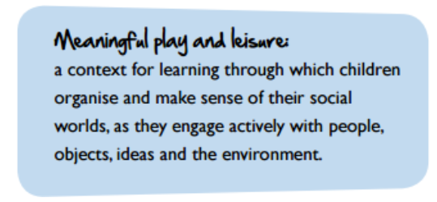
Our Service delivers a Program, which aligns with the Australian Government’s National Quality Framework “My Time Our Place”. The Framework aims to maximise learning outcomes for children who participate in OSHC programs and offers guidance to educators on specific areas to support children in their learning and development Please take the time to visit the National Quality Framework “My Time Our Place” website https://www.acecqa.gov.au/sites/default/files/2018-02/educators_my_time_our_place.pdf to view the framework that guides our program.

- OSHC Staff
We would also like to introduce you to our team:
Nominated Supervisor | Peter Smith
OSHC Coordinator | Anjuli Pickering
OSHC Educator | Darcy Fuller
OSHC Educator | Rory Paterson
OSHC Educator | Candi Godbaz
OSHC Educator | Tim Biddle
OSHC Educator | Brooke Lever

- Nutrition
Our service endeavours to provide a variety of nutritious food such as:
- plenty of vegetables, beans and lentils
- fruit
- breads, cereals, rice, pasta, noodles (mostly wholegrain), and other grains like oats and barley
- milk, yoghurt and cheese
We ask for suggestions from children and families into the planning our menus.
Fresh water is available at the service at all times.

- Orientation

The orientation may include information about the following: participation of families in the service’s program, sign in/out procedures, fee payment options, location of the parent area, location of relevant documents, introduction of educators, and the family code of conduct and parent concern procedures. As the typically OSHC families start at various times throughout the year please make a time with the coordinator to assist you with your family’s orientation to our OSHC service.

Please feel free to pop in for a visit before your child starts their first day at OSHC.

Please do not hesitate to contact me if you have any further questions
via email spr_oshc@rok.catholic.edu.au
Service Mobile Phone Number 0417 753 258.

Kind regards
Anj Pickering
Coordinator

